There is a GitHub repo that you as a DevOps engineer are maintaining:

You might be required to perform the below tasks:

* Add users to this repo
* Monitoring vulnerabilities on this repo
* Build CI/CD pipeline on this repo
* List users who have access to this repo (settings -> collaborators)
* Check resigned users are not having access to repo

To do all this, instead of login to GitHub repo every time .. we can write a shell script. This shell script needs integration with GitHub

To talk to any application (GitHub, Jenkins, GitLab, Kubernetes etc.) we can either use

* API request
* CLI
* Launch an EC2 instance in AWS (ubuntu os)
* Connect to EC2 instance from SSH client
* Clone the git repo where the shell scripts are stored in ec2 instance

<https://github.com/iam-veeramalla/shell-scripting-projects>

* Pass your github username and token for authentication

We generally give username and pwd, for APIs we provide api token for authentication purposes

settings 🡪 developer settings 🡪 Personal access tokens 🡪 generate new token

* Export these from CLI



* Provide organization name and Repo name as arguments

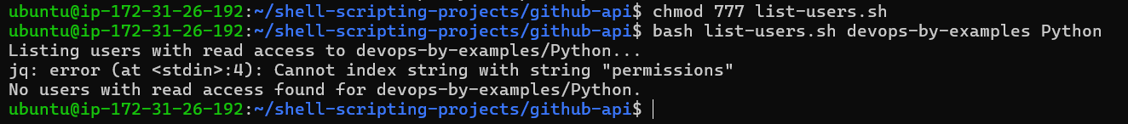

Because we don’t have access to this organisation

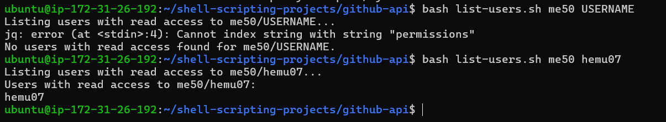

* Helper function not working why?